Photographing Overseas - Cadillacs in Cuba, Markets in Mumbai?
Travel photography is very popular. You fly off to exotic locations and shoot whatever catches your eye. You will be visiting all the key landmarks, so why not photograph them? Unfortunately we sometimes end up with a rather mixed set of images taken in unsuitable weather or light. Far stronger images are available at the click of a mouse.
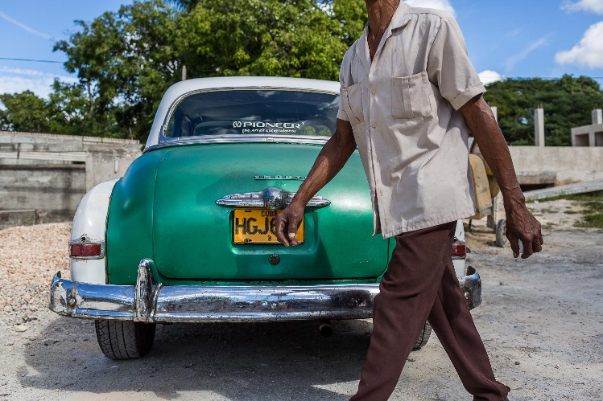
Here’s a different approach. Many of us already have a preference for landscapes, street photography or wildlife for instance, so why draw on that expertise in exotic locations? Our photos will be stronger and more original than the standard travel shots. And we need to focus, don’t we?
Guided photographic tours can take to the most photogenic parts of the world. All the arrangements are made for you, you will be in good company and you’ll get some great shots. But tours can be very expensive. They suit beginners needing tuition, and those with specialist interests.
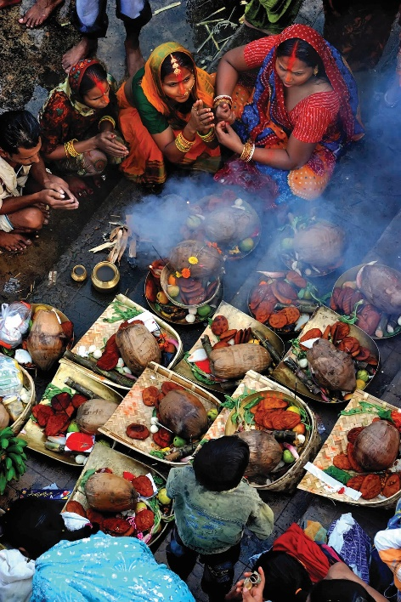
It takes a lot of time and effort to plan your own trip, but you can choose your own dates and go where you like. Alternatively, a fellow photographer or a long-suffering partner will provide company and support, but you must be willing to compromise.
Detailed planning beforehand will always pay off. Look at images online and visit forums for advice. You’ll need a daily itinerary; build in some flexibility where you can.
The average DSLR owner isn’t in his or her first flush of youth, so be sensible when it comes to packing. Pack individual items carefully to avoid damage and make sure it is insured. It is possible to hire photographic equipment in some countries. Take backup batteries and lots of memory cards. Consider using a portable hard disk to back up your images as you go. These items add to the overall cost, but keep in mind how much it is costing you to get your images!

Wildlife Photography Overseas Street Photography Overseas
Event Photography Overseas Landscape Photography Overseas

Wildlife Photography Overseas
Shooting wildlife in its natural habitat is very demanding. Wildlife is elusive and photographers need expertise, patience and perseverance. Beginners can make a start by photographing fauna in captivity, or in your garden or local park. Practice controlling motion in the frame and varying the depth of field. You will be shooting in natural light only. Good destinations include national parks and wildlife reserves.
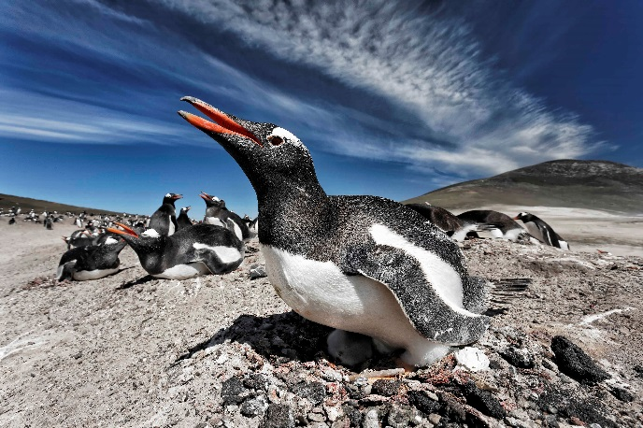
You need to be properly equipped for a wildlife trip overseas. A powerful telephoto lens is essential to shoot animals at a distance. With a full frame camera you can crop to fill the frame with your subject, without losing image quality. A backup camera body will prevent your trip being ruined by camera failure, and it will allow you to use two lenses at the same time without having to swap them over. Image quality will be higher with two lenses than with a single superzoom lens.
A tripod or a monopod can be very useful, but keep in mind how far you plan to carry your kit. Airline-style wheeled camera bags are a worthwhile alternative to heavy photo rucksacks. Take plenty of memory cards, a backup camera battery, a travel adapter and a torch. If you can, use a notebook computer to backup and review your images. Don’t wait until you get home to discover some of your images are not as good as you hoped!
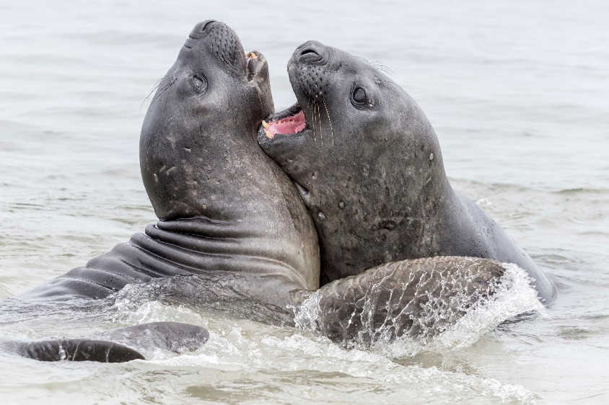
Research the species you plan to shoot using specialist books and online sources. Certain times of the day will be more productive. The mating season will produce strong images and the animals will pay less attention to photographers.
Many species are protected and you may need a permit to photograph them. A local contact is useful. Plan for all types of weather. Being cold or wet when you are waiting for an animal to appear is very off-putting.
Plan your timetable carefully and realistically. Some locations cater for photographers, and facilities such as hides are placed to give you every chance of getting the shot. It is well worthwhile getting to know the other photographers you will meet on your trip. They will usually share with you some good spots to shoot, as well as places to stay.
If you find you have set your sights rather high, try your luck at images of more common species. Wildlife competitions are won by photographers entering images of common species. The strength of the image comes from the light in the frame, the animal’s behaviour and the background.

Street Photography Overseas
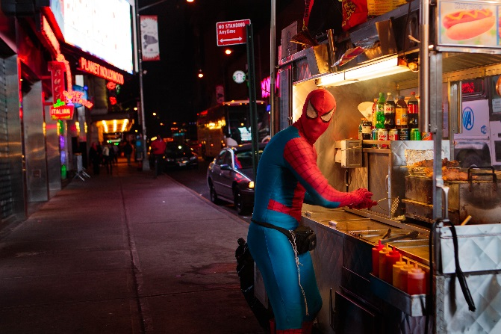
Street photographers need to be prepared to take their shot because their subject is unpredictable and fleeting. It is impractical for them to carry a full set of photo equipment; a DSLR and a good quality, medium wide-angle to telephoto zoom lens usually suffices. More recently compact system cameras have become popular with street photographers. They offer a reasonable balance between image quality and portability. Compact system controls are a little different so get to know them before your trip.
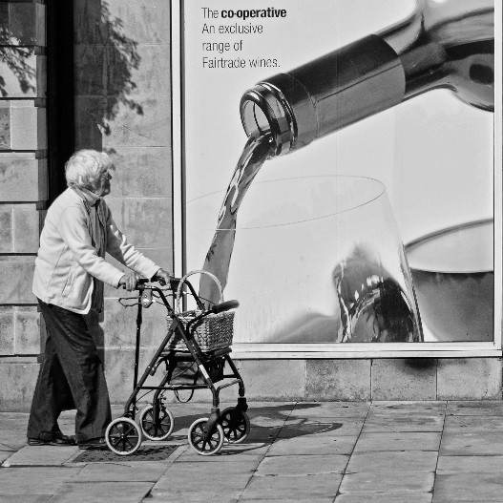
Most street photographs illustrate an element of human behaviour within an urban environment, so in some ways it’s similar to wildlife photography. Strong composition separates the good street photograph from an average record shot. The urban architecture is an important aspect of the photo. Many photographers select the location for their shot, and they then wait for the perfect subject to walk into it. The variety of urban light sources will produce colour casts, so prepare beforehand by looking at how you can adjust your camera’s white balance settings.
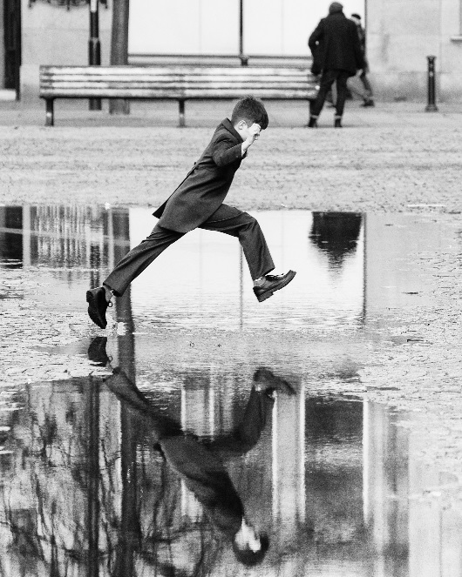
Ideally you want to be familiar with your locations, and this takes time. So don’t move on to quickly. You will discover some naturally photogenic locations where opportunities present themselves e.g. parks, outdoor cafes, meeting places. Beginners will probably get the best results by ensuring reasonable sharpness throughout the frame, later on you can experiment with varying your depth of field. You might also be tempted to use fill in flash in high contrast situations, but keep in mind most street photographers prefer to remain as invisible as possible.
To start with, pick a number of likely venues which are fairly close to each other. Decide which time of day would be best for you to visit, perhaps to coincide with planned events. Find vantage points which will produce interesting compositions and allow you to shoot without being too conspicuous. Revisit on a regular basis, and get to the point where you are waiting for the missing ingredient, and then capture it when it appears. Look for compositional elements which offer an original perspective on contemporary fashions and behaviours. It takes just a little experience before you can decide whether to persevere in your chosen spot, or move on to a new location.
Event Photography Overseas
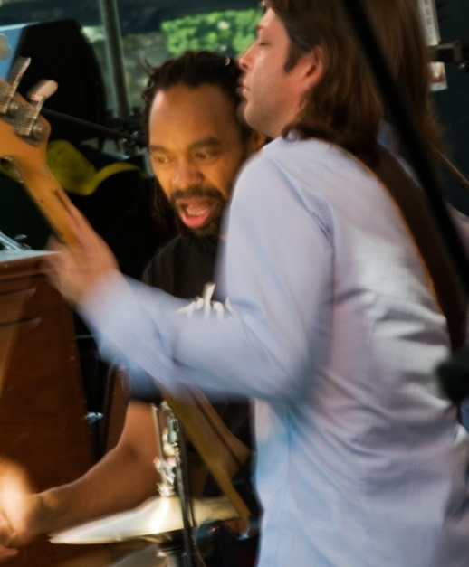
Event photography has the advantage of predictability; you know when your event will take place and you can plan accordingly. That said, you only get the one opportunity to get each shot. Try to get privileged access; your images will be stronger and more personal than the ones taken by the members of audience. You might get permission to take images onstage, to visit backstage, or be given a trackside location to shoot from.
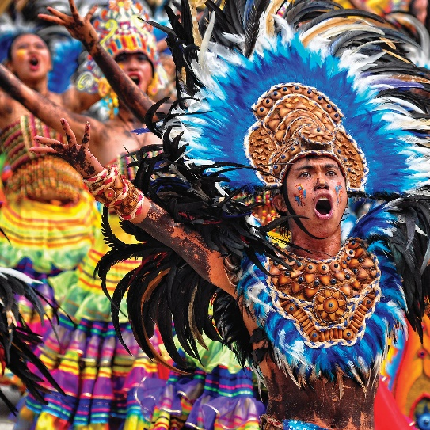
The equipment you’ll need will depend partly on the type of event. A range of lenses and a DSLR would be a good choice, and typically with event photography you won’t need to carry your equipment very far. But you may need to plan for a lot of bright lights affecting your metering and generating unpleasant colour casts.
Persistence during the planning stage will usually pay off. Get in contact with the venue early on and emphasise that you are arriving from overseas. Your first job is to find out who is in a position to assist you; junior staff will have little freedom to act. Be clear about what you are looking for, and try to come across as responsible and respectful. There may be privileged access available to a few photographers who get in touch well in advance. Don’t try to wrap up your negotiations too quickly. Often a letter or email informing key parties about your project will be appreciated, and a visit to the site a few days beforehand may be help to clinch the deal.
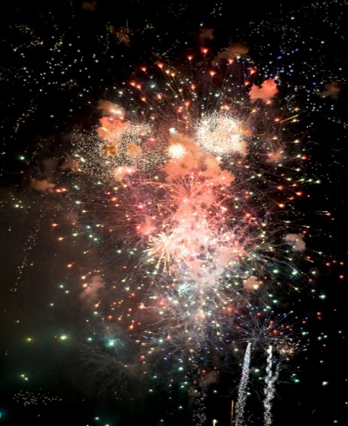
In any event you are likely to be photographing with certain rules in force, so make sure you know what they are and that you observe them at all times. Being positive and respectful will generate trust, to the point that subsequent requests are more likely to be granted.
You can also get in touch with local photographers and ask for their advice, they may have useful contacts. Try reputable online forums, or write directly to photographic clubs and societies.
There are lots of local venues for you to practice your skills before your trip, for instance sports matches, amateur theatrical productions, and horse and greyhound racing. Experiment with a range of techniques and then evaluate your images afterwards. It’s probably best to decide beforehand what equipment and camera settings you are going to use for your practice session, rather than trying to experiment in a noisy or dark setting.
Landscape Photography Overseas
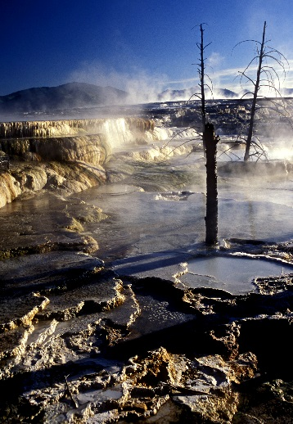
It has been said that of all the photographic genres, landscape photography requires the greatest amount of planning. You want to arrive at each location when it is at its best, having taken into account the season, the time of day, and the weather. And don’t be shy of bad weather, it is very photogenic!
The amount of equipment you take on your trip will depend partly on your transport arrangements. Having use of a vehicle is ideal. You can adjust your route as you see fit, you can use it to store your equipment and also to shelter sometimes.
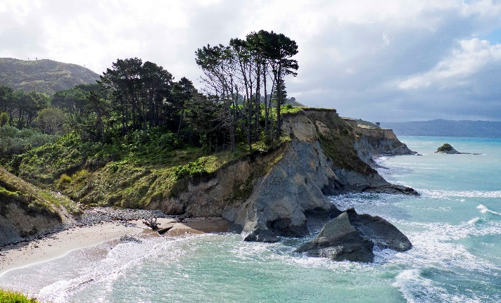
Most photographers take one or two DSLR bodies, a wide-angle lens and a telephoto lens. A tripod with a remote release is very helpful; you get excellent quality images in low light without camera shake. It also slows you down, and your compositions will become stronger. You will need robust clothing, backup batteries and extra memory cards. Make sure you can protect your equipment in adverse weather.
Some of the most dramatic landscapes have been photographed in the warm light of early morning, so book accommodation nearby. A typical landscape photographer would start shooting at dawn, continue for 3 hours and then take a break. Midday light is harsh but it will transform woodland. It is also a useful time to explore other locations for the following day. Start photographing again in the afternoon and continue until dark.
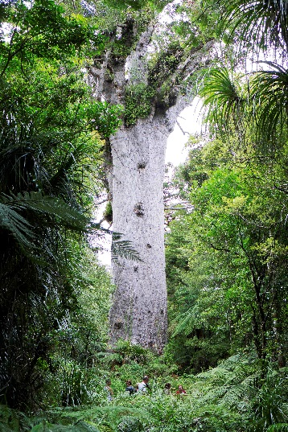
National parks are wonderful for landscape photography. The finest landscapes are readily available and access is straightforward. The images will be more original if you explore the less visited areas, and if you also take intimate close-ups. Don’t forget to insure your equipment, national parks can be rich picking grounds for thieves!
Photography in some locations overseas is banned. As a general rule avoid photographing military bases, prisons and airfields.
When using wide-angle lenses, make sure your image contains some foreground interest. An extended depth of field will suit many locations, but try using larger apertures to draw the viewer’s attention to a particular element in the frame.
Do try to take some practice shots before your trip. You need to be comfortable with your equipment and sure that everything is working properly. You can then compare your results with images online.

